OneLineCRM
Description
This AMI contains an Apache Tomcat web server pre-configured to run on an Amazon EC2 instance. Once deployed, the Tomcat server can be accessed via the instance's public IP address on port 80. This setup is ideal for hosting websites, web applications, and API services with minimal configuration.

Prerequisites
• An AWS account.
• Basic knowledge of Amazon EC2 and Tomcat.

Launching the AMI
1. Log in to your AWS account and navigate to the EC2 Dashboard.
2. Launch Instance: Click on the "Launch Instance" button and choose the "AWS Marketplace" tab. Search for the relevant AMI and select the AMI from the list.
3. Choose an Instance Type: Select an instance type that suits your workload. Click “Next: Configure Instance Details.”
4. Configure Instance Details: Set your instance configurations as needed. Here, ensure that the “Auto-assign Public IP” is set to “Enable” if you are in a VPC that does not do this by default. This setting will ensure your instance is accessible over the internet. If this option is not visible or available, it might be because your VPC settings auto-assign public IPs by default or you need to modify your VPC settings. Click “Next” until you reach the “Configure Security Group” step.
5. Configure Security Group: Create a new security group with the following rules:
• Type: HTTP, Protocol: TCP, Port Range: 80, Source: Anywhere (0.0.0.0/0, ::/0) This rule allows traffic on port 80 to access the Tomcat server. Click “Review and Launch.” (if you want to OS ssh access added there also port 22)
6. Review: Check your instance settings and click “Launch.”
7. Select a Key Pair: Choose an existing key pair or create a new one. You will use this to SSH into your instance. Acknowledge that you have access to the selected key pair and click “Launch Instances.”
- Access application OneLineCRM, browse to URL after launch
http://IP_OF_EC2/crm
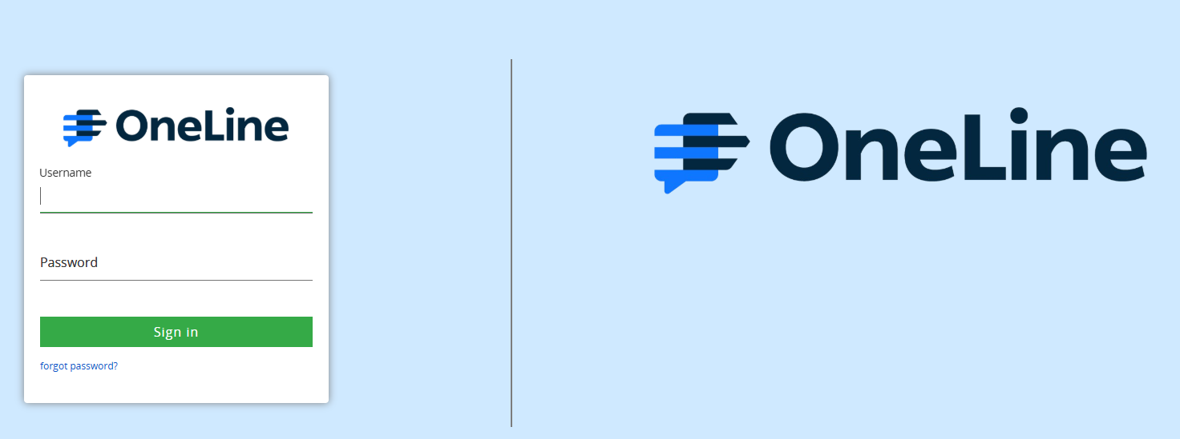
Login with:
username: vlyounkin
password: Vy159!159 (You will be able to change it later)
The user expected to see:
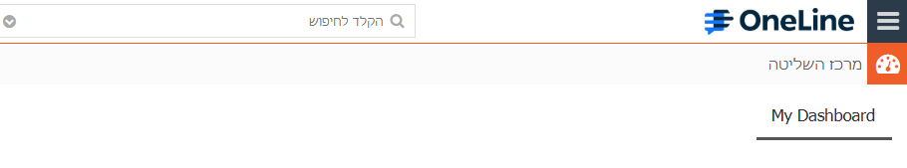
Connecting to OS of your Instance
To connect to your instance for configuration changes or troubleshooting:
1. Open a Terminal on your computer.
2. Connect via SSH: Use the command below, replacing “<YourKeyPair.pem>” with the path to your key pair file and “<PublicIpAddress>” with your instance’s public IP address.
ssh -i <YourKeyPair.pem> ec2-user@<PublicIpAddress>

