OneRisk
Description
This AMI contains an Apache Tomcat web server pre-configured to run on an Amazon EC2 instance. Once deployed, the NGINX server can be accessed via the instance's public IP address on port 80. This setup is ideal for hosting websites, web applications, and API services with minimal configuration.

Prerequisites
- An AWS account.
- Basic knowledge of Amazon EC2 and Apache Tomcat.

Launching the AMI
- Log in to your AWS account and navigate to the EC2 Dashboard.
- Launch Instance: Click on the "Launch Instance" button and choose the "AWS Marketplace" tab. Search for the relevant AMI and select the AMI from the list.
- Choose an Instance Type: Select an instance type that suits your workload. Click “Next: Configure Instance Details.”
- Configure Instance Details: Set your instance configurations as needed. Here, ensure that the “Auto-assign Public IP” is set to “Enable” if you are in a VPC that does not do this by default. This setting will ensure your instance is accessible over the internet. If this option is not visible or available, it might be because your VPC settings auto-assign public IPs by default or you need to modify your VPC settings. Click “Next” until you reach the “Configure Security Group” step.
- Configure Security Group: Create a new security group with the following rules:
  - Type: HTTP, Protocol: TCP, Port Range: 80, Source: Anywhere (0.0.0.0/0, ::/0) This rule allows traffic on port 80 to access the NGINX server. Click “Review and Launch.”
  - Type: RDP, TCP, Port Range 3389 and Source your computer IP to allow RDP access to instance.
- Review: Check your instance settings and click “Launch.”
- Select a Key Pair: Choose an existing key pair or create a new one. You will use this to RDP into your instance. Acknowledge that you have access to the selected key pair and click “Launch Instances.”
After launching the instance:
- Find the Public IP: Navigate to the EC2 Dashboard, locate your new instance, and copy its public IP address.
Access OneRisk: Open a web browser and enter the public IP address. You should see the product’s landing page, indicating that your server is running and accessible.
- Open your web browser.
- Go to the following address: http://PublicIPofInstance/MSP
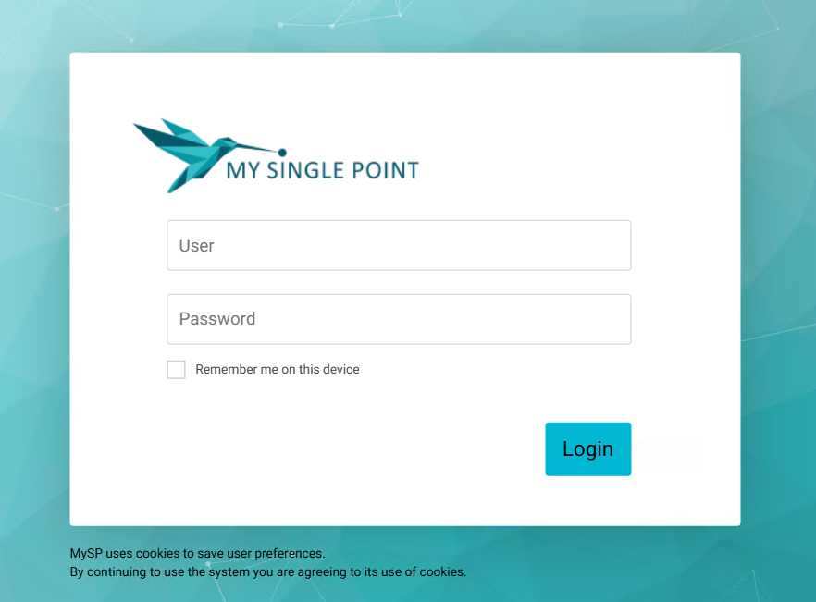
- Enter the username: administrator
- Enter the password: One12345% (you will be able to change it later)
- Open the Side Panel

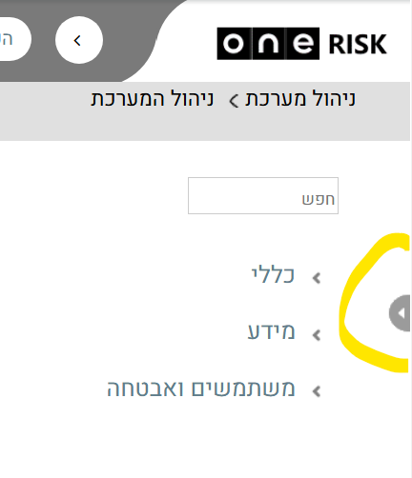
- Click on “ניהול סיכונים”
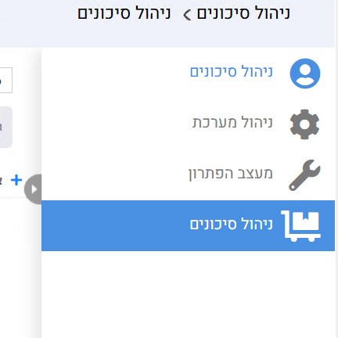

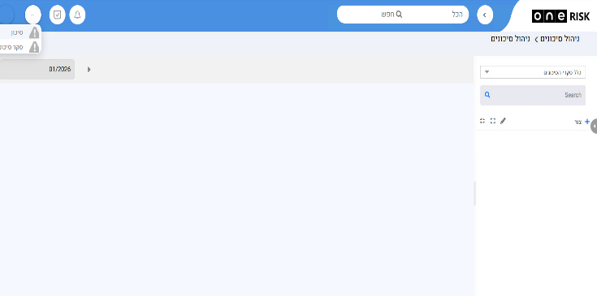

Connect via RDP to OS level:
Get Administrator Password from AWS page:
- GO to AWS Instance -> connect –> RDP client -> Get Password and put there your key recently created and retrieve Administrator password
Open a Remote Desktop Connection on your computer put Public IP of your instance and recently retrieved Administrator password

Support
Support is provided during working hours Sun to Thu between 08:00-17:30. We recommend you open a call in our web Site at: https://www.one1.co.il.
We are here to help with any questions or issues related to the deployment and operation of your Apache Tomcat server on AWS.

